**IVEN Parameter Change Tutorial**January 2020  
Jessica E. Forsyth

IVEN has been designed so that users can change features of the scripts to fit their biological system most accurately. Therefore the scripts are not compiled and can easily be accessed. IVEN for MATLAB can be easily changed using the MATLAB software (used when running IVEN). IVEN for Python can be changed in any interpreter such as Jupyter Notebook, PyCharm or equivalent (even Notepad if you are a confident Python script writer).

This document contains a few pointers for what you can change and what you should change in terms of file import etc.

MATLAB:

1. We have integrated a GUI where you are able to select how you would like to threshold the Delaunay Triangulation (if at all). A window will appear after correction of the outside versus inside cells, that should look like this

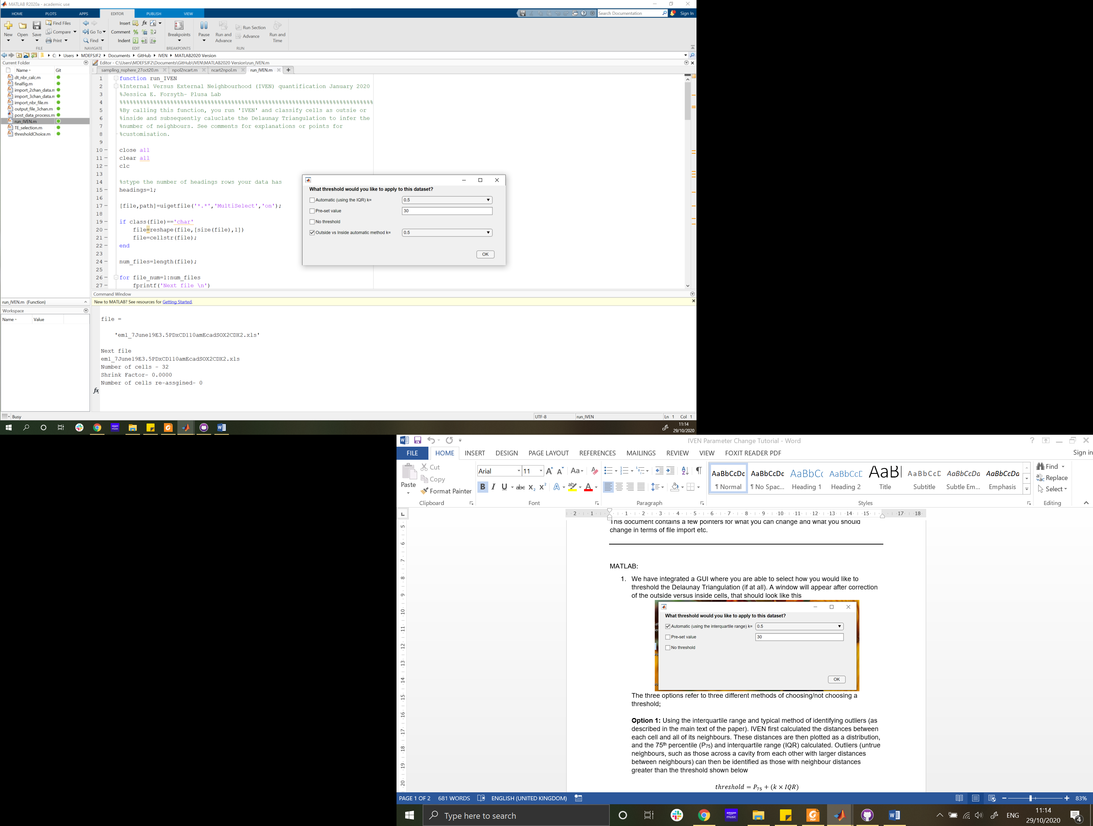

The three options refer to three different methods of choosing/not choosing a threshold;

**Option 1:** Using the interquartile range and typical method of identifying outliers (as described in the main text of the paper). IVEN first calculated the distances between each cell and all of its neighbours. These distances are then plotted as a distribution, and the 75th percentile (P75) and interquartile range (IQR) calculated. Outliers (untrue neighbours, such as those across a cavity from each other with larger distances between neighbours) can then be identified as those with neighbour distances greater than the threshold shown below

$$threshold=P_{75}+(k×IQR)$$

where $k$ is a parameter you choose in the drop down menu. This parameter effectively changes how strict your thresholding of neighbours is, the larger the value of $k$ the bigger the threshold. We chose the value of $k$ by comparing distances of known true neighbours and known false neighbours and choosing the optimum value of $k$ for all stages.

**Option 2:** Using a predefined value as a threshold, for instance a known cell diameter or known feature size of your sample. This value can then be changed at will and will be output in the Command Window for each file processed.

**Option 3:** No thresholding of the Delaunay Triangulation. This can be selected if you have a relatively uniform set of cells with no cavities or potential for untrue neighbours.

**Option 4:** Similar to option1, but instead calculates threshold for inside versus outside cells.

We have incorporated this GUI to ensure that an informed decision is made for each data set independently and that the threshold chosen can be output for each file analysed. Although this GUI appears for each file analysed, you may want to change the automatic values of the options to save time if processing many files. If you do want to change these go to the function ‘thresholdChoice.m’, and change the relevant fields.

1. Changing the size of the markers within the interactive figures (due to sample size/ axes ratio).

Change the value of ‘markersize=125’ on line 33 in ‘outside_selection.m’and line 16 in ‘final_fig.m’.

Python:

1. IMPORTANT: how many headers the excel file you want to import has. My data (Example Data), has two ‘title rows’ (rows 1 and 2, check the Excel file). However your data that you compile yourself may have a different number of title rows.

Line 22 : data = pd.read_excel(fname, header=[0,1])

If for instance you have one title row, change this line to,

Line 22 : data = pd.read_excel(fname, header= 0),

or if you had for instance three title rows change the line to,

Line 22 : data = pd.read_excel(fname, header= [0,1,2]).

1. Thresholding of the number of neighbours. We do this to account for the cavity in the preimplantation blastocyst. We calculate this threshold using the inter quartile range in 75th percentile as explained in more detail in the paper.

**Using Option 1:**

Uncomment line 53 and comment out line 54 in ‘run_IVEN.py’.  
To change the value of $k$ (or manipulate the way the threshold is calculated) go to ‘funcs.py’ and locate ‘def threshold_f(points, num_cells, nbrs):’ on line 167.

If you would like to change the value of $k$ used to calculate the threshold, go to line 183.

**Using Option 2/3:**

Uncomment line 53 and comment out line 54 in ‘run_IVEN.py’.

The comment out lines 172-185 using ‘#’ and then change the value of thresholdval on line 186.

**Using Option 4:**

Comment out line 53 and uncomment line 54 in ‘run_IVEN.py’.  
To change the value of $k$ (or manipulate the way the threshold is calculated) go to ‘funcs.py’ and locate ‘def threshold_f_cellspec(points, num_cells, nbrs,TE):’ on line 193.

If you would like to change the value of $k$ used to calculate the threshold, go to line 214 in ‘funcs.py’.

1. Changing the size of the markers within the interactive figures (due to sample size/ axes ratio).

Change the value in ‘s=[50]’ on lines 85 and 268 in ‘funcs.py’.

1. These are the most obvious and system dependent parameters you will need to change, but please feel free to change other parameters and interact with IVEN however you want to.